HT1 User Guide

VIAMED is an application that is used to display medical services that are offered by a variety of providers throughout Croatia. Within the app there are many different ways to see the information that is available.

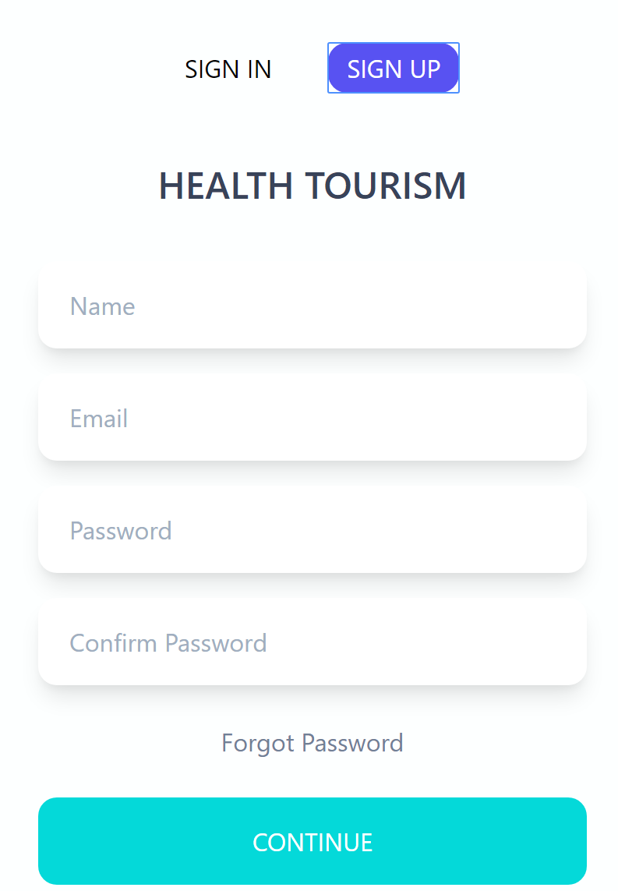

Sign Up:

Signing up for an account in VIAMED is a simple 4 step process. First enter your name on the first line. After that enter your email that you would like to use. This email will be used to communicate with clinics. Come up with a password, it is important to always use at least 1 capital, 1 lowercase and try to include at least 1 number or special character (123$%^).

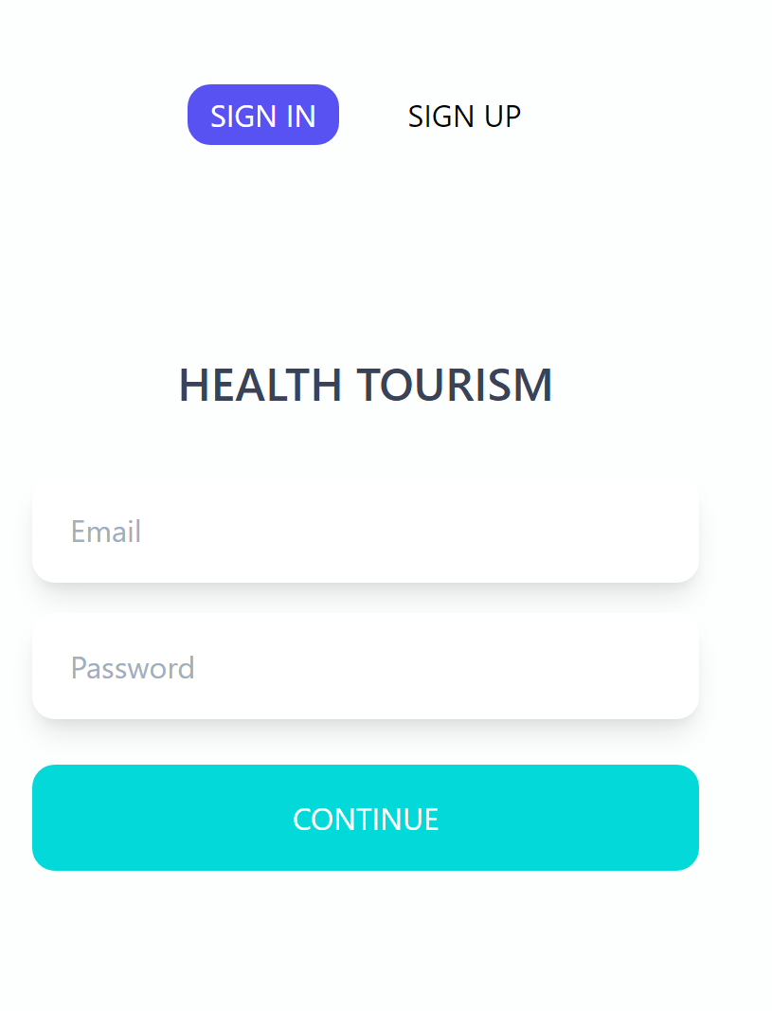

Signing In

After you successfully sign up for an account use the email and password you created to sign into VIAMED!

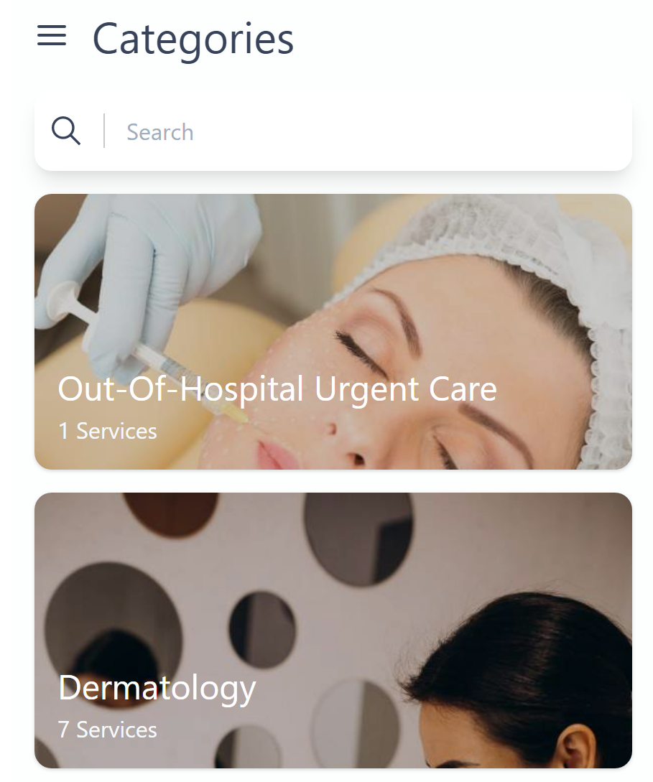

Starting Screen

After sign in you will get into the app. At this point you are presented with the first method to search for services within VIAMED. This method of searching will display each of the categories of the various services. To see the whole listing scroll vertically through the items that come up in the search.

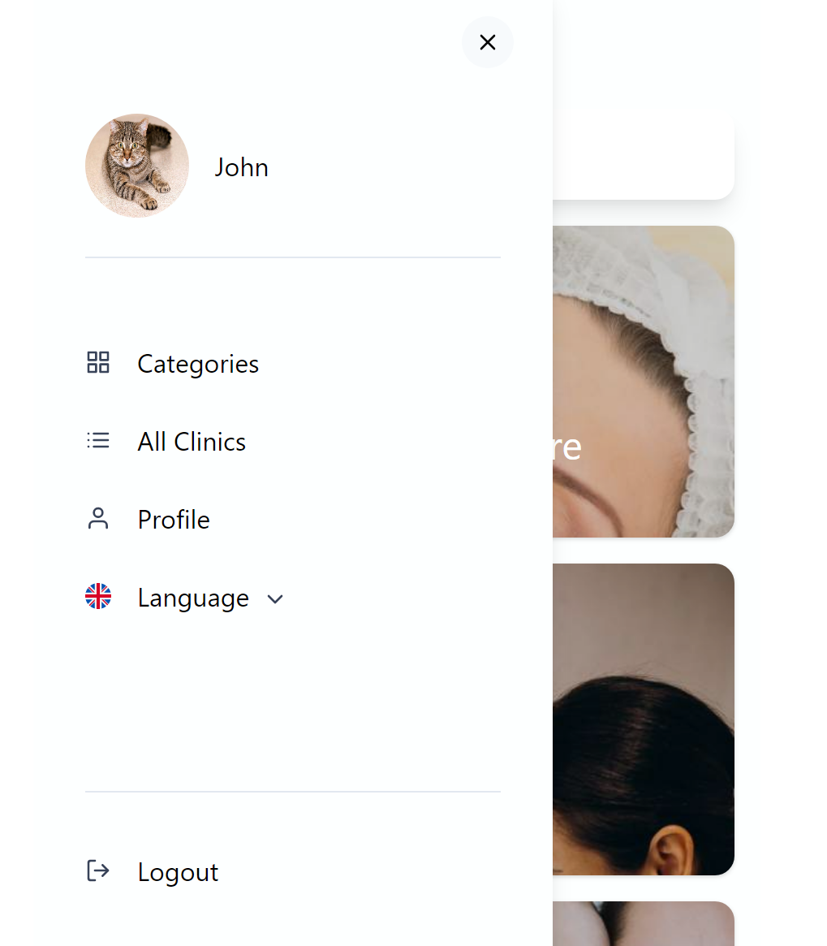

Changing Settings

To navigate throughout VIAMED there is a hamburger menu button at the top left of the screen. After selecting the button you will see the screen to the left. From here you have the ability to change how you search for services. 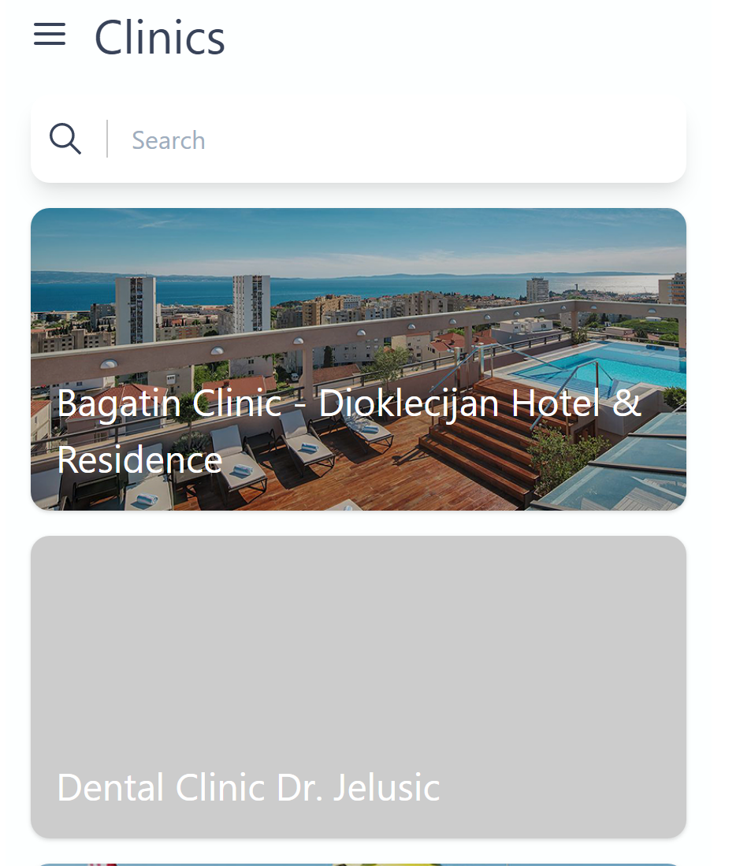

All clinics options will be displayed if you choose that option.

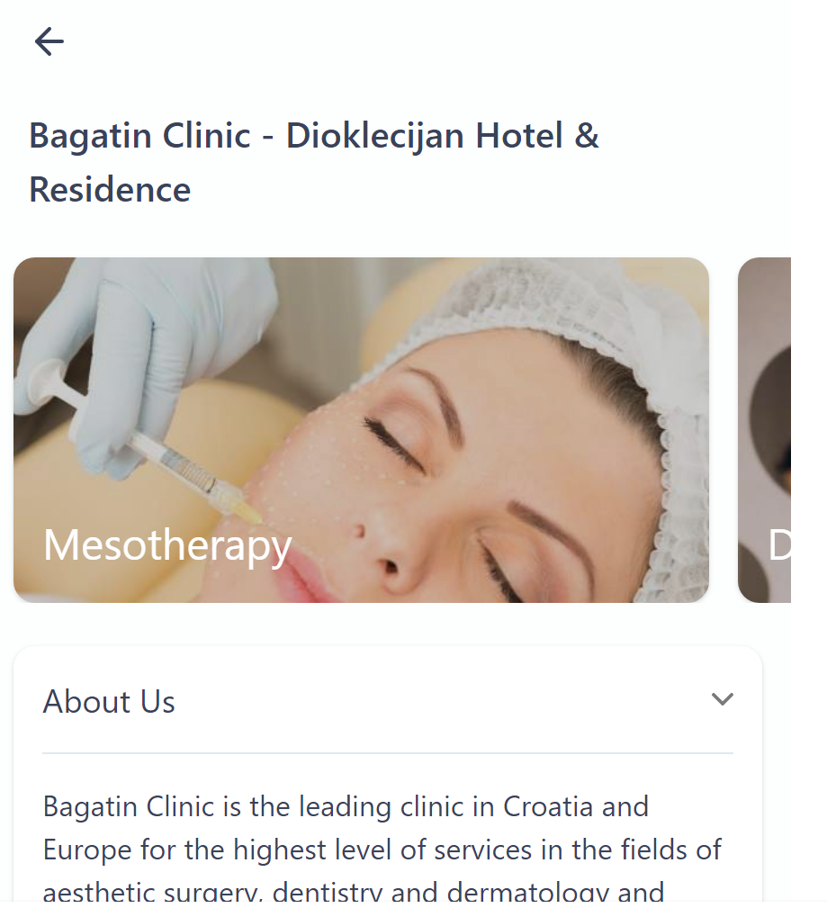

Clinic Information

Click on the clinic you want to visit and then scroll left and right to view the services that are available.Upon selection of a clinic you will see information regarding their geographic location as well as contact information. To navigate to their website to schedule an appointment select the “contact” button. To send an email to the clinic select the small mail button to the left of the presented email address. To call, select the phone icon to the left of the phone number.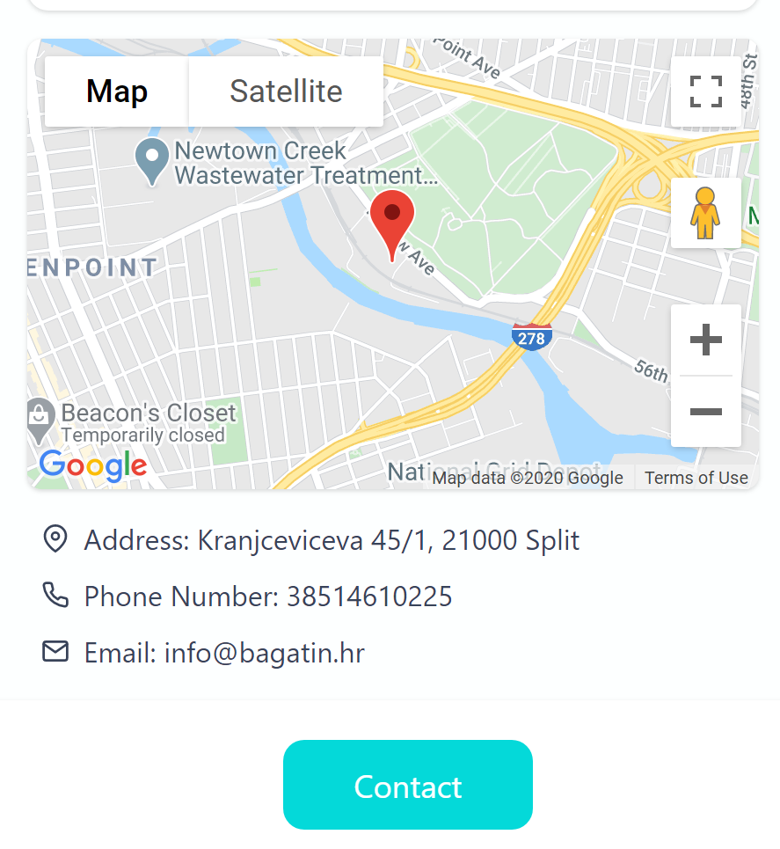

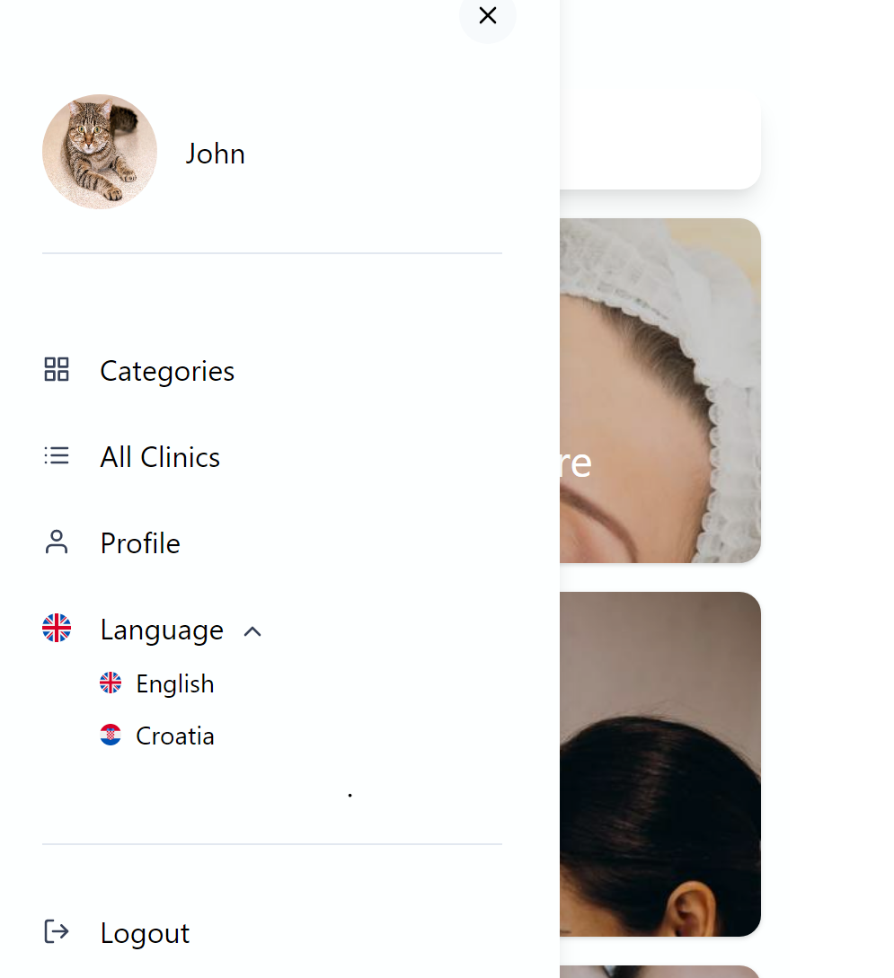

Language Filtering

The application is currently available in both English and Croatian. After you sign into the the application using your profile your language option is a setting that can be switched

Logging out

Logging out of VIAMED is quick and easy. Simply select the button that says “Logout”.

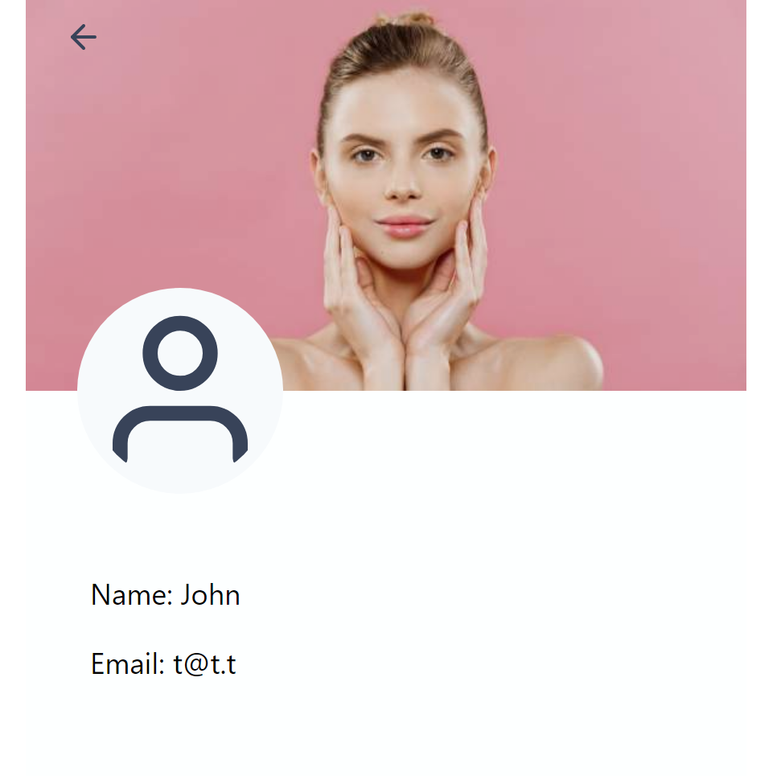

Profile Listing

To see your profile click the “Profile” button from under the navigation area. This will bring you to your profile page. To go back to the main page of VIAMED click the arrow in the top left.

At this point each of the functions of VIAMED have been documented above. If you are in need of assistance or have found a bug or issue please contact [help@viamed.com](mailto:help@viamed.com) for more information. Thank you for choosing VIAMED and have a great day